**User Story 1: Import .csv or .txt file**

**As** a Field Engineer, **I want to** load valid well trajectory data points (less than 100001), stored in txt file or csv file, into the program, **so that** I can visualize the target well trajectory.

**Priority:** 1

**Dependency:**

**Effort Estimation(day):** 1

**User Story Description:** A valid well trajectory data point should contain and only contain x,y,z coordinate. No missing coordinates or extra coordinates are allowed. The coordinates should be numerical and arranged in the order of x, y, z. The x,y,z coordinates should be separated by commas (for example: 1,1,0).

**Acceptance Criteria:**

AC1 (happy path):

**Given** the program is run successfully and Well Trajectory Visualization form is ready.

**When** I click the Open File button at the Toobar or the Open File button at File under Main Menu.

**Then** a open file dialogue is opened, which only display .csv or .txt file.

AC2 (happy path):

**Given** the open file dialogue only for .csv or .txt file is opened.

And less than 30 well trajectories have been loaded into the system.

**When** I select an accessible .csv or .txt file contains less than 100001 valid well trajectory data points.

**Then** a message box is popped up with text "New Well loading from {file path} succeed." within 60 seconds.

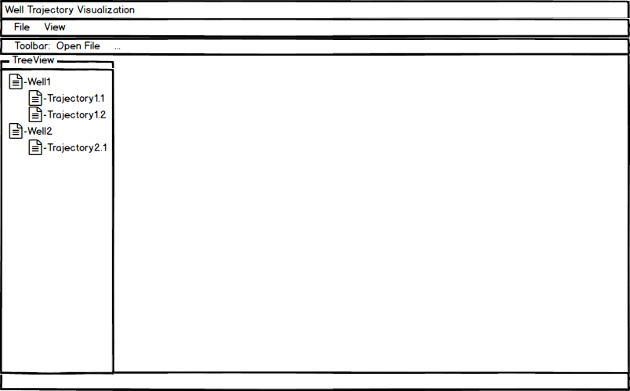And the file name of the selected file is listed in the Treeview (Fig.1).

Fig.1

AC3 (negative path):

**Given** the open file dialogue only for .csv or .txt file is opened.

**When** I select a inaccessible .csv or .txt file.

**Then** a message box is popped up with error message”Loading {file path} failed. Error: File not accessible.”

AC4 (negative path):

**Given** the open file dialogue only for .csv or .txt file is opened.

And less than 30 well trajectories have been loaded into the system.

**When** I select a .csv or .txt file that has extra coordinate or coordinates.

**Then** a message box is popped up with error message ”Loading {file path} failed. Error in Line {line number}: Data overflow.”

AC5 (negative path):

**Given** the open file dialogue only for .csv or .txt file is opened.

And less than 30 well trajectories have been loaded into the system.

**When** I select a .csv or .txt file that has missing coordinate or coordinates.

**Then** a message box is popped up with error message ”Loading {file path} failed. Error in Line {line number}: Data lost.”

AC6 (negative path):

**Given** the open file dialogue only for .csv or .txt file is opened.

And less than 30 well trajectories have been loaded into the system.

**When** I select a .csv or .txt file that has non numerical data and contains less than 100001 valid well trajectory data points.

Then a message box is popped up with error message ”Loading {file path} failed. Error in Line {lineNumber}: Non-float numbers in data.”

AC8 (negative path):

**Given** the open file dialogue only for .csv or .txt file is opened.

And less than 30 well trajectories have been loaded into the system.

**When** I select a .csv or .txt file that has already been loaded into the system.

**Then** a message box is popped up with error message.

AC9 (negative path):

**Given** the open file dialogue only for .csv or .txt file is opened.

And less than 30 well trajectories have been loaded into the system.

**When** I select a .csv or .txt file that has already been loaded into the system.

**Then** a message box is popped up with error message.

AC10 (negative path):

**Given** the open file dialogue only for .csv or .txt file is opened.

And less than 30 well trajectories have been loaded into the system.

**When** I select a .txt file in which the coordinates are not separated by commas contains more than 100000 valid data points.

**Then** a message box is popped up with error message”Loading {file path} failed. Error in Line {line number}: Data overflow..”

AC11 (negative path):

**Given** the open file dialogue only for .csv or .txt file is opened.

And 30 well trajectories have been loaded into the system.

**When** I select an accessible .csv or .txt file.

**Then** a message box is popped up with error message”Loading {filePath} failed. Reach the well trajectory loading limit.”

**User Story 2: Visualize well trajectory**

**As** a Field Engineer, **I want** to see the main view, top view and left view of the well trajectory displayed in one page, **so that** I can have a rough understanding of the well trajectory profile in different projection plane and imagine the well trajectory in 3D.

**Priority:** 1

**Dependency:** Import .csv or .txt file

**Effort Estimation(day):** 1

**Acceptance Criteria:**

AC1 (happy path):

**Given** at least one well trajectory has been imported into the system.

And less than 10 tab pages have been opened.

**When** I double click the target well trajectory in the Treeview.

**Then** the main view, top view and left view of the well trajectory are displayed at one tab page (Fig.2).

And the tab page is labeled with the file name of the well trajectory (Fig.2).

And the tab page is focused (Fig.2).

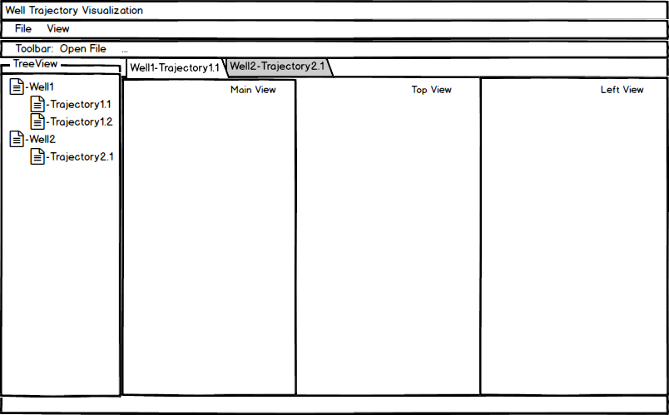

Fig.2

AC2 (happy path):

**Given** at least one well trajectory has been imported into the system.

And at least 1 tab page has been opened.

**When** I click the close button of one tab page.

**Then** that tab page should be closed.

AC3 (happy path):

**Given** at least one well trajectory has been imported into the system.

And at least 1 tab page has been opened.

**When** I click one tab page.

**Then** that tab page is focused.

And the main view, top view and left view of that well trajectory are displayed at the tab page (Fig.2).

AC4 (negative path):

**Given** at least 11 well trajectories have been imported into the system.

And 10 tab pages have been opened.

**When** I double click a unopened well trajectory in the Treeview.

**Then** a message box is popped up with error message “Only 10 pages can be opened. Please close a page before opening a new one.”

**User Story 3: Highlighted well trajectory data points**

**As** a Field Engineer, **I want to** see the well trajectory data points highlighted on the well trajectory, **so that** I can know the position of the well trajectory data points.

**Priority:** 3

**Dependency:** Import .csv or .txt file, Visualize well trajectory

**Effort Estimation(day):** 0.5

**Acceptance Criteria:**

AC1 (happy path):

**Given** at least one well trajectory has been imported into the system.

And less than 10 tab pages have been opened.

**When** I double click the target well trajectory in the Treeview.

**Then** the main view, top view and left view of the well trajectory are displayed at one tab page.

And the tab page is labeled with the file name of the well trajectory.

And the tab page is focused.

And the well trajectory data points are highlighted using circle.

**User Story 4: Add axis to plot**

**As** a Field Engineer, **I want to** see the axis of the well trajectory projection in the three views, **so that** I can get some basic information of the well trajectory including closure distance and etc.

**Priority:** 3

**Dependency:** Import .csv or .txt files, Visualize well trajectory

**Effort Estimation(day):** 0.5

**Acceptance Criteria**

AC1(happy path):

**Given** at least one well trajectory has been imported into the system.

And less than 10 tab pages have been opened.

**When** I double click the target well trajectory in the Treeview.

**Then** the main view, top view and left view of the well trajectory are displayed at one tab page.

And each view has corresponding axis which could cover the scope of the data points distribution.

**User Story 5: Save plot to files**

**As** a Field Engineer, **I want to** save the projection plot to image files (.bmp, .jpeg, .png), **so that** I can reopen them with other professional image viewer applications for further use.

**Priority:** 2

**Dependency:** Import .csv or .txt files, Visualize well trajectory

**Effort Estimation(day):** 1

**Acceptance Criteria**

AC1(happy path):

**Given** the program is run successfully and at least one tab page is opened.

**When** I select one tab page and click the Save File button at the Toobar or the Save File button at File under Main Menu.

**Then** a list menu is shown for choosing the view to save.

**Given** the Save File button at the Toobar or the Save File button at File under Main Menu is clicked.

**When** I click one menu item of view.

**Then** a list menu is shown for choosing the view to save.ilename.jectory if use image t save file dialogue is opened, which only display bmp, jpeg or png files.

AC3 (happy path):

**Given** the save file dialogue only for bmp, jpeg or png files is opened.

**When** I input the name of image file (xx) and choose the image format (.yy) to save as, and click the Confirm button.

And the file name has no conflict with existing files.

**Then** a message box is popped up with text "Well trajectory projection view plot saved." within 10 seconds.

And the image file named “xx.yy” is created in the chosen folder.

And the chosen plot is saved correctly to the image file.

AC4 (Alternative path):

**Given** the program is run successfully and no tab page is opened.

**When** I click the Save File button at the Toobar or the Save File button at File under Main Menu.

**Then** no save file dialogue is opened and nothing happens.

AC5 (happy path):

**Given** the save file dialogue only for bmp, jpeg or png files is opened.

**When** I input the name of the image file (xx) and choose the image format (.yy) to save as, and click the Confirm button.

And there is only one existing file with duplicate filename.

**Then** a message box is popped up with text "Are you sure to overwrite the existing file?" within 10 seconds.

AC6 (happy path):

**Given** a message box is popped up with text "Are you sure to overwrite the existing file?" within 10 seconds

**When** I click ”Yes”.

**Then** the image file “xx.yy” is created in the folder.

And the chosen plot is saved correctly to the image file.

AC7 (happy path):

**Given** a message box is popped up with text "Are you sure to overwrite the existing file?" within 10 seconds

**When** I click ”No”.

**Then** no image file is created in the folder.

AC8 (negative path):

**Given** the save file dialogue only for bmp, jpeg or png files is opened.

**When** I input the name of the image file (xx) and choose the image format (.yy) to save as, and click the Confirm button.

And there is only one existing file with duplicate filename, which is inaccessible to write on.

**Then** a message box is popped up with text "Error: no write access to file" within 10 seconds.

And the existing file is not overwritten.

**User Story 6: Annotation**

**As** a Field Engineer, **I want to** see the annotation of the trajectory data points on the three views, **so that** I can get some basic information of the well trajectory, including the x, y, z coordinate of the well trajectory data points, well depth and etc.

**Priority:** 3

**Dependency:** Import .csv or .txt files, Visualize well trajectory, Highlighted well trajectory data points

**Effort Estimation(day):** 1.5

**Acceptance Criteria:**

AC1 (happy path):

**Given** at least one tab page with three views of trajectory is opened.

**When** I select a tab page and check the Show Coordinate menu item at the context menu.

**Then** the annotations are displayed besides the data points at the three views of the selected tab page.

AC2 (happy path):

**Given** at least one tab page with three views of trajectory is opened.

**When** I uncheck the Show Coordinate menu item at the context menu.

**Then** the annotations are disappeared at the three views of the selected tab page.

AC3 (happy path):

**Given** at least one tab page with three views of trajectory is opened.

**When** I select one tab page and move the mouse over one data point of the well trajectory and hang over.

**Then** the annotations of that data point is displayed beside the data point.

AC4 (happy path):

**Given** at least one tab page with three views of trajectory is opened and the mouse is hang over one data point.

**When** I move the mouse away from one data point.

**Then** the annotations of that data point is disappeared.

**User Story 8: Zoom**

**As** a Field Engineer, **I want to** zoom the three views, **so that** I can see the magnification of certain details.

**Priority:** 3

**Dependency:** Import .csv or .txt files, Visualize well trajectory

**Effort Estimation(day):** 2

**Acceptance Criteria:**

AC1 (happy path):

**Given** at least one tab page with three views of trajectory is opened.

**When** I select a tab page and select an area on a view by mouse.

**Then** the view display area is filled by the selected area.

And moving to other area of the whole trajectory is allowed for users.

AC2 (happy path):

**Given** at least one tab page with three views of trajectory is opened.

**When** I select a tab page and select the whole display area of a view by mouse.

**Then** the view display area is filled by the whole view.

**User Story 9: Preview**

**As** a Field Engineer, **I want to** preview the three views before officially open it, **so that** I can only open the three views needed.

**Priority:** 3

**Dependency:**

**Effort Estimation(day):** 1

AC1 (happy path):

**Given** at least one well trajectory has been imported into the system.

And less than 10 tab pages have been opened.

And no preview tab page has been opened.

**When** I single click a unopened well trajectory in the Treeview.

**Then** the main view, top view and left view of the well trajectory are displayed at one preview tab page.

And the preview tab page is labeled with the italic file name of the well trajectory.

And the preview tab page is focused.

AC2 (happy path):

**Given** at least one well trajectory has been imported into the system.

And less than 10 tab pages have been opened.

And one preview tab page has been opened.

**When** I single click an unopened target well trajectory in the Treeview.

**Then** the preview tab page is closed.

And the main view, top view and left view of the well trajectory are displayed at one preview tab page.

And the preview tab page is labeled with the italic file name of the well trajectory.

And the preview tab page is focused.

AC3 (happy path):

**Given** at least one well trajectory has been imported into the system.

And less than 10 tab pages have been opened.

And one preview tab page has been opened.

**When** I double click an unopened target well trajectory in the Treeview.

**Then** the preview tab page is closed.

And the main view, top view and left view of the well trajectory are displayed at one tab page.

And the tab page is labeled with the regular file name of the well trajectory.

And the tab page is focused.

AC4 (alternative path):

**Given** at least one well trajectory has been imported into the system.

And less than 10 tab pages have been opened.

And one preview tab page has been opened.

**When** I double click an opened target well trajectory in the Treeview.

**Then** the preview tab page is not closed.

And the tab page of the target well trajectory is focused.

AC5 (alternative path):

**Given** at least one well trajectory has been imported into the system.

And less than 10 tab pages have been opened.

And one preview tab page has been opened.

**When** I single click an opened target well trajectory in the Treeview.

**Then** the preview tab page is not closed.

And the tab page of the target well trajectory is focused.

AC6 (happy path):

**Given** at least one well trajectory has been imported into the system.

And less than 10 tab pages have been opened.

And one preview tab page has been opened.

**When** I select the preview tab page and click the close button at tool bar.

**Then** that preview tab page should be closed.

AC7 (alternative path):

**Given** at least one well trajectory has been imported into the system.

And less than 10 tab pages have been opened.

And one preview tab page has been opened.

**When** I select a tab page (not preview tab page) and click the close button at tool bar.

**Then** that preview tab page is not closed.

And the selected tab page is close.

**User Story 10: Default Page**

**As** a Field Engineer, **I want to** see the shortcuts information of the major action at default page, **so that** I can easily know the shortcuts of the major action.

**Priority:** 3

**Dependency:**

**Effort Estimation(day):** 0.5

**Acceptance Criteria:**

AC1 (happy path):

**Given** the program can be run successfully.

**When** I run the program.

**Then** the default page includes the shortcuts information of Load Well Trajectory, Save View, Open Customized View Editor, View Source File should be displayed.

AC2 (happy path):

**Given** at least one well trajectory has been imported into the system.

And no tab pages are opened.

And default page is opened.

**When** I double click the target well trajectory in the Treeview.

**Then** the default page should be invisible.

And the tab page should be opened.

AC3 (happy path):

**Given** at least one well trajectory has been imported into the system.

One tab page is opened.

**When** I close the tab page.

**Then** the default page includes the shortcuts information of Load Well Trajectory, Save View, Open Customized View Editor, View Source File should be displayed.